The day the rain wasn’t listening!

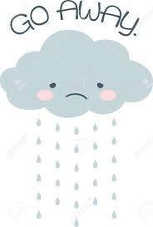
By
Mel Churton
January 2023
One day it rained and rained. The grass got wet, the road got wet, and we got wet. And then everything got wet. It rained some more. That's enough now, we thought. “You can stop now!” we said, But the rain wasn't listening.

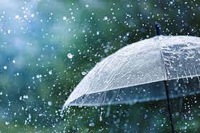

The grass got so wet it couldn’t take any more rain. The water didn't have anywhere to go. So, it started to get higher and higher. We always wanted a swimming pool at our place, but not a muddy brown one and not inside the house!
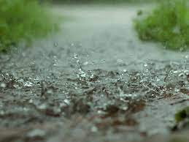
It was getting darker and wetter, and it was a bit scary. We cuddled together to be brave. Soon the water was up to the windows. “You can stop now!” we said, but the rain was not listening!
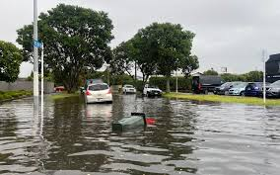

Some nice people came with torches and some blankets and towels. They checked we were ok and said “Come with us”. They had a safe place for us to sleep that night. As we left our house, the car was floating on the drive. We always wanted a spa, but not inside the car!
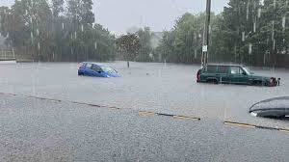
We all lay down together in a church hall, warm and dry. Some people were snoring and farting louder than the rain! “You can stop now!”, we said, but the rain kept falling. We listened to the rain on the roof until we drifted off to sleep.
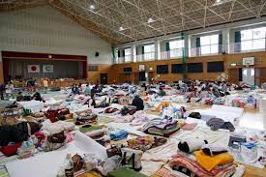

The next morning all around us were rivers of mud and bit of furniture and tree branches and other crazy stuff. There was even a trampoline in the middle of our street!

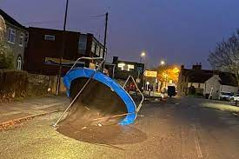

But the rain wasn’t as hard. Maybe it has switched on its listening ears at last! And
there were lots of kind people with brooms and buckets and shovels and even a guy in a big yellow digger.
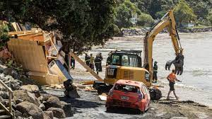

They had come to help us make things ok again!
We shovelled and we brushed and we washed things with clean water. We pulled up our mucky carpets and we put all our treasures in a box so they could be saved.

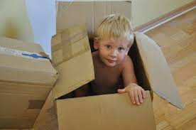
Everything was stinky but we were ok. Our house could be fixed and nice people were giving us stuff to use until we got sorted again. And it had finally stopped raining!

The dog decided to go out to play, but we’d have enough of swimming for a while. We’ll just stay right here in our dry, clean house!

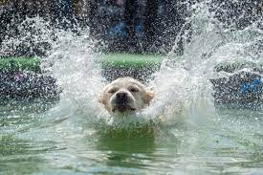
Things to talk about:

- What was unusual about the rain in the story?

- Why did they people in the story say “the rain wasn’t listening”?

- How did the people in the story feel when the water went into their house and car?

- What did the helpers do to make the family feel safe?

- After the big flood, how did the house get cleaned up?

- Why didn’t the kids want to go swimming with the dog?

- If your friend’s house got flooded, how could you make them feel a bit better?

Pictures to colour:

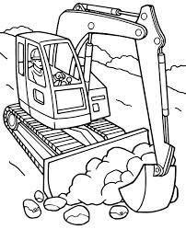

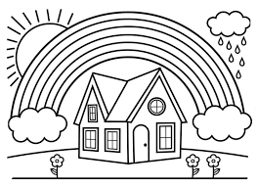
If you are worried, remember:

√ Most days the rain has its “listening ears” on!

√ If rain is really bad, people will help you get out of your house to somewhere safe

√ After a bad storm, things look really yucky for a while, but broken stuff can be fixed and dirty stuff and be cleaned up

√ As long as you are safe, it ok. People will help to make things better once the rain stops.

√ Sing this loud and the rain might just hear you:

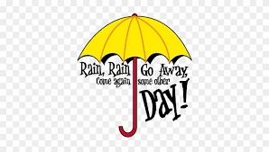
Draw a picture of a machine that could be used to catch rain or push flood water away from homes:

